ALL OUTPUTS OF WEEK 1 ASSIGNMENT:-

- Create a webpage with a title, a main heading, and two paragraphs.
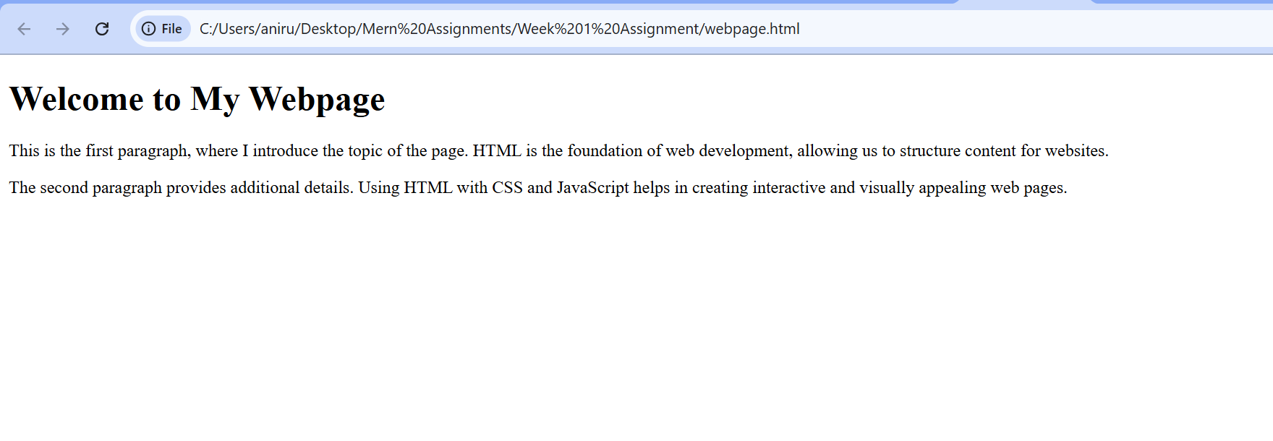
- Add an image with a caption below it and center both on the page.

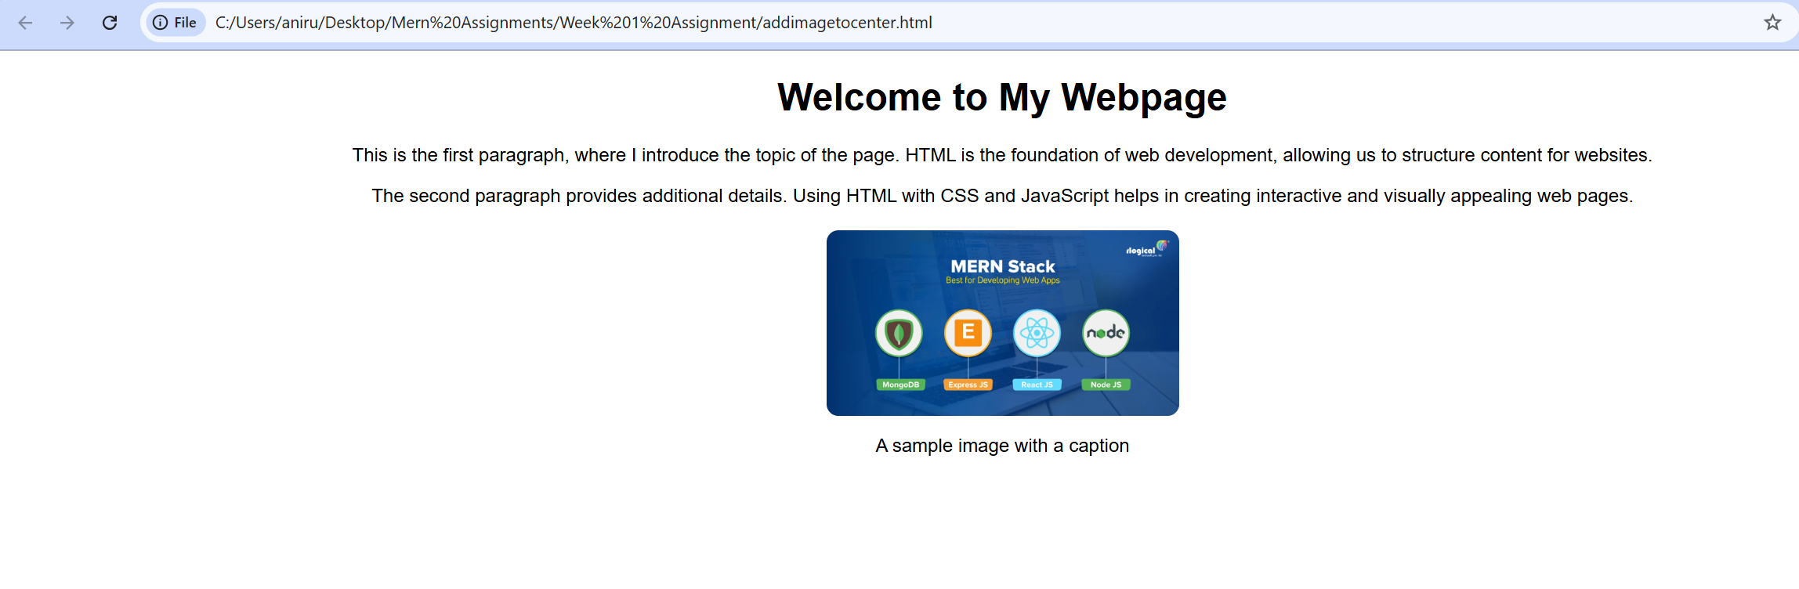
- Style all paragraphs with a different font family, line height, and text alignment.
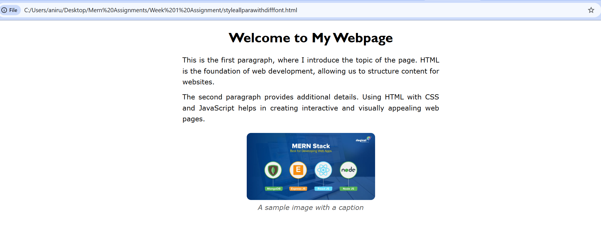
- Design a styled button with padding, border, and a hover effect.
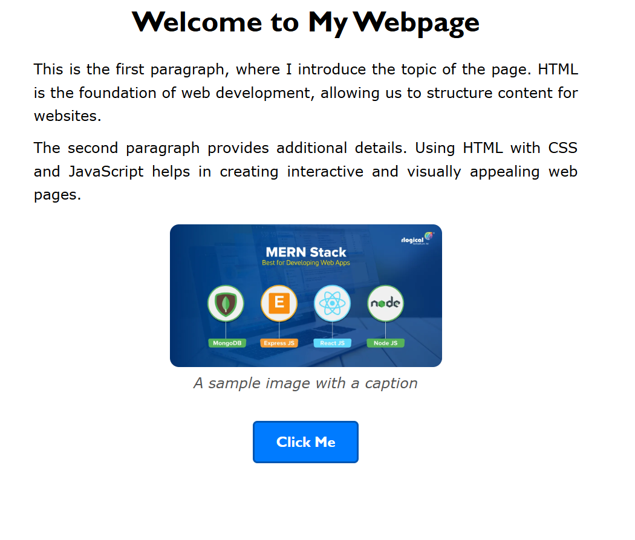
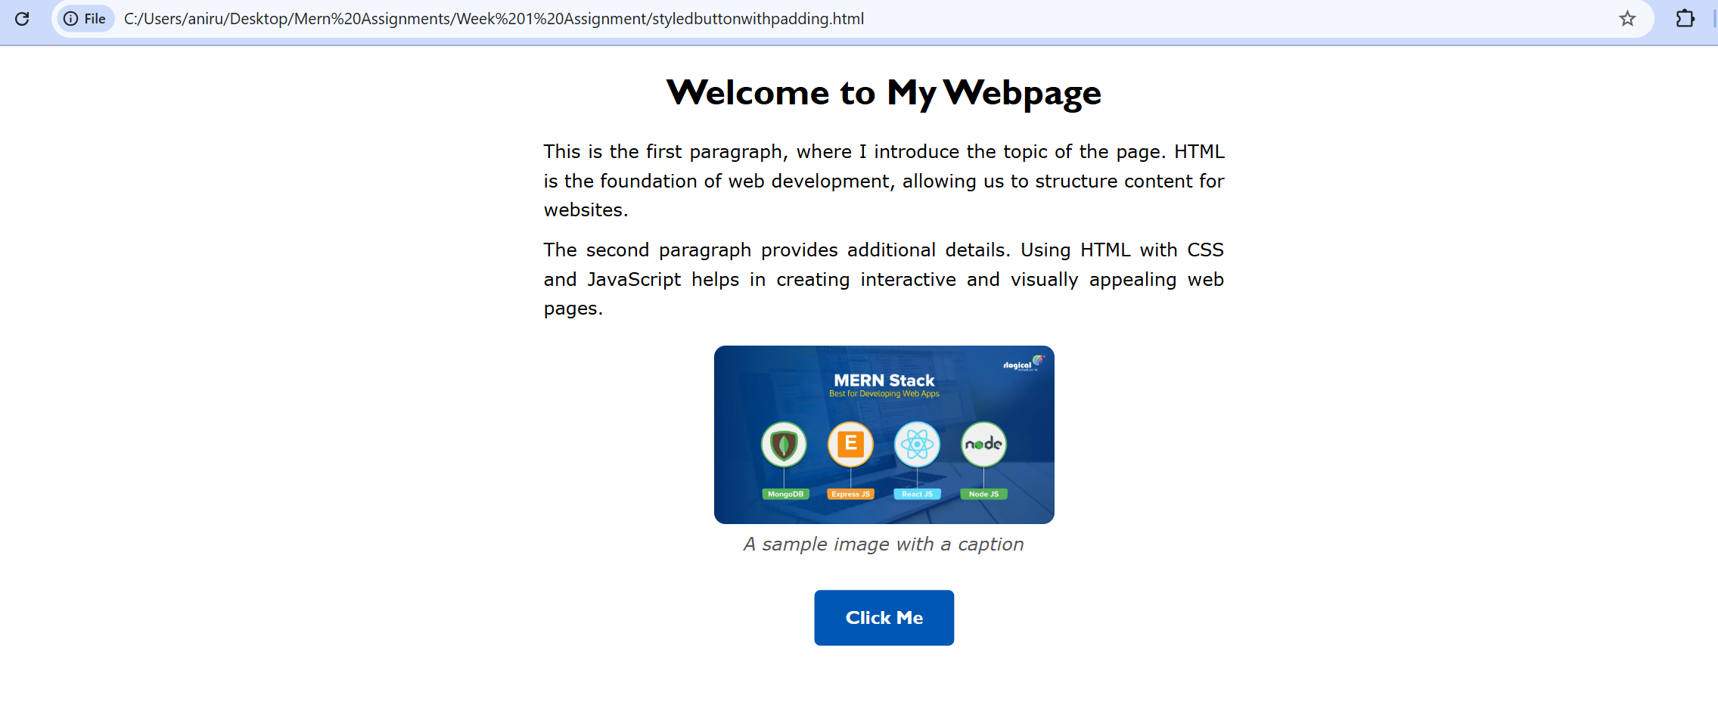
- Create a simple table with three columns and three rows, and a basic form with two input fields and a submit button